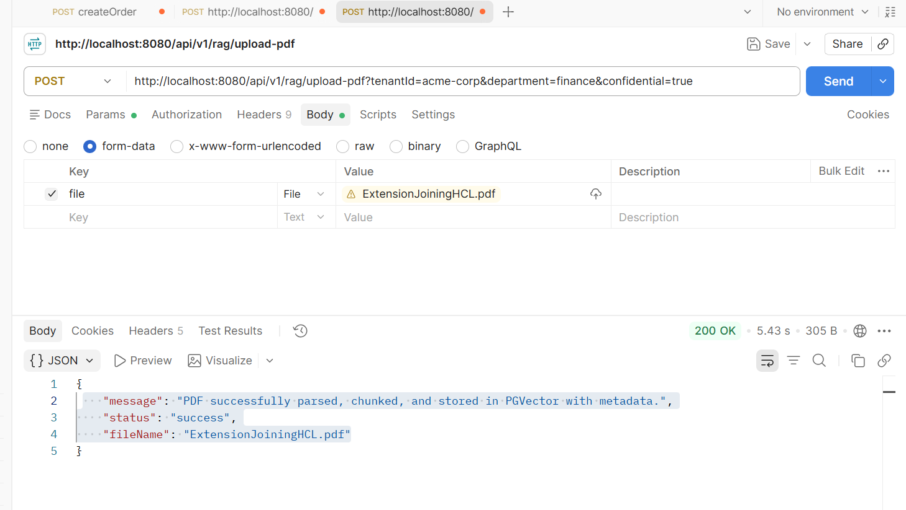
Testing the Endpoint with cURL:
curl -X POST "http://localhost:8080/api/v1/rag/upload-pdf?tenantId=acme-corp&department=finance&confidential=true" \
-F file=@/path/to/your/local/document.pdf

